How to Create SFTP User without Shell Access on CentOS/RHEL 7

## Step 1 – Create Account

First of all, create a user account to use for sftp access. Below command will create user named **sftpuser** with no shell access.

sudo adduser --shell /bin/false sftpuser

sudo passwd sftpuser

## Step 2 – Create Directory

Now, create the directory structure to be accessible by sftp user.

sudo mkdir -p /var/sftp/files

Change the ownership of the files directory to sftp user. So that the sftpuser can read and write on this directory.

sudo chown sftpuser:sftpuser /var/sftp/files

And set the owner and group owner of the /var/sftp to root. The root user has read/write access on this access. Group members and other accounts have only read and execute permissions.

sudo chown root:root /var/sftp

sudo chmod 755 /var/sftp

## Step 3 – Configure SSH for SFTP

Now edit the SSH configuration file in a text editor

sudo vim /etc/ssh/sshd_config

and add the following settings at end of file.

Match User sftpuser

ForceCommand internal-sftp

PasswordAuthentication yes

ChrootDirectory /var/sftp

PermitTunnel no

AllowAgentForwarding no

AllowTcpForwarding no

X11Forwarding no

Save the configuration and restart SSH service to apply changes.

sudo systemctl restart sshd.service

## Step 4 – Test SFTP Connection

I am using FileZilla for the connection to the SFTP instance from my Windows systems. Linux desktop users can also use Filezilla for connection.

For the Linux server, users can use sftp command-line utility to connect to remote sftp instance.

**$ sftp sftpuser@sftp.tecadmin.net**

Connecting to sftp.tecadmin.net...

sftpuser@sftp.tecadmin.net's password:

sftp>

Output

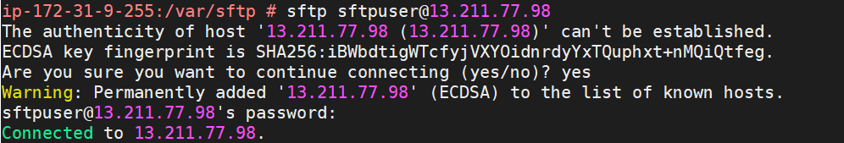

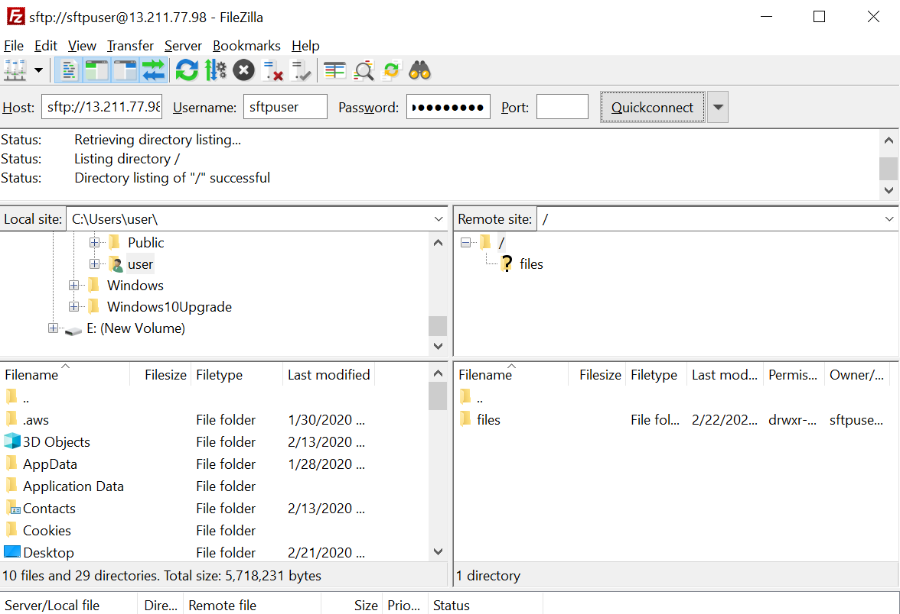

<https://tecadmin.net/create-sftp-only-user-centos/>